**AMBIT BACKEND**

User device mai jakar agar sab sai pehlay **USER_ID** mai 265 filter karengay phr hum **IS_MARKED_TRUSTED** ko 1 karday tw wo phr otp nahi mangay ga.

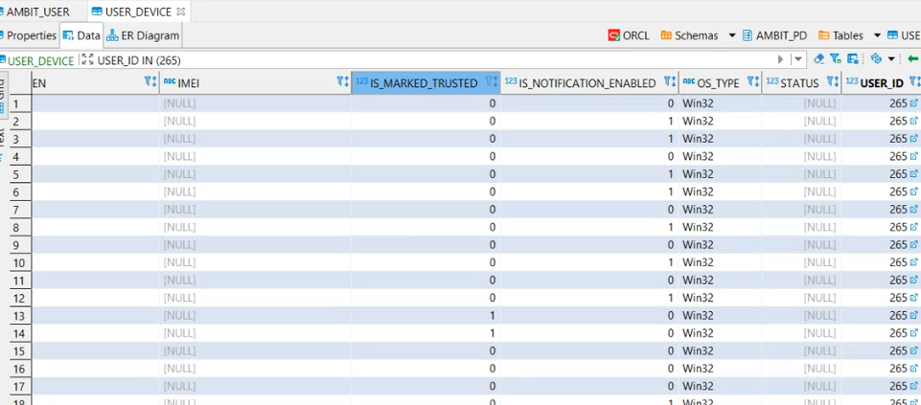

Resource file mai hamara koe code nahi hota iska maqsad yai hota hai yai request ko repeat karay ga or phr usko response day ga.

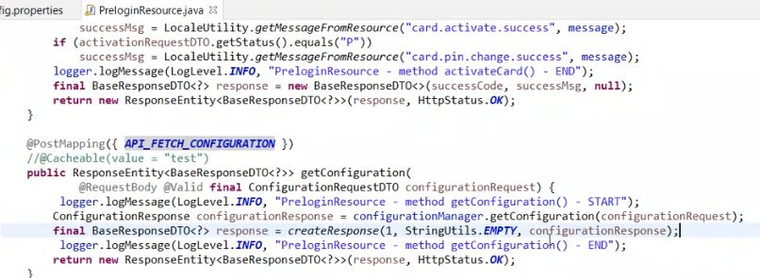

phr us k liye hum manager banatay hai us mai hum interfaces banatay hai interfaces hum is liye banatay takay hum multiple implematation karsakay

for example : is waqt hamaray pass ambit project mai 2 major flavour hai ambit box mai 1 digital version hai or 1 box version hai

box version ka maqsad yai hai k hum saray operation lets say benificiary management etc sb hamary pass hoti hai hum sirf financial transaction k liye middle ware use kartay yai hamara

box version hota hai jis k andar hum saari management khud kartay

digital version k liye 3rd party rdv hota hai usi k andar saari management hoti hai

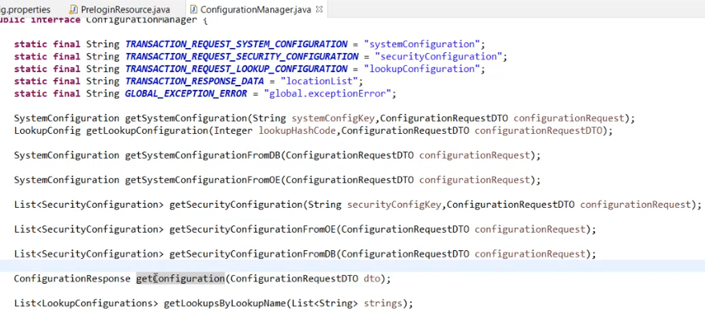

Phr us k baad hum ajatay hai get configuration ki implementation par

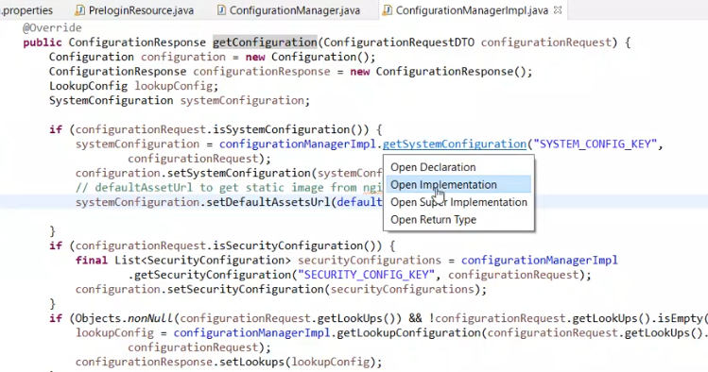

configurationmanagerimpl ki jo file hai asal mai isay hum kehtay hai manager layer isi k andar hum saari business logic perform kar rahay hotay

us k baad agar system config ki implementation dekhay tw

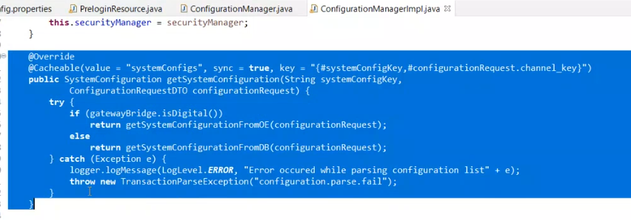

Yaha jo logic ha iwo check karay ga k ambit box mai digital version hai ya box version hai agar digital hai tw if ki condition run hogi.

agar hum application.properties mai check karay tw wo abhi ambit box par hoga tw hum usay digital kar saktay

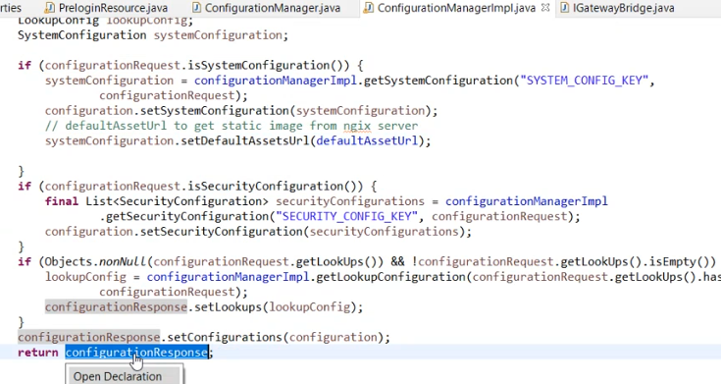

Logics hai is mai further data jo hai configuration mai set kartay rehtay hai or akhir mai response return kardetay hai

Agar aap dekhay tw get configuration ki request jo aap nay send kit hi tw yahi information post man nay send kit hi

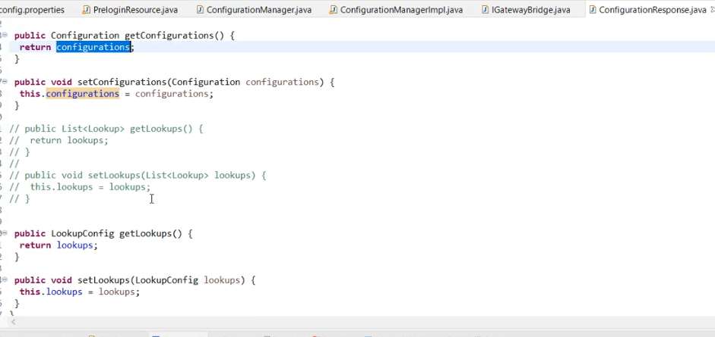

Lookup k andar aap k pass multiple hierarchy hosakti hai

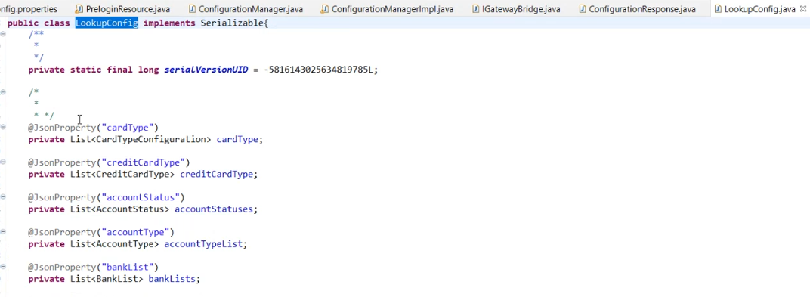

Isi tarah sai aap k pass configuration hai aap configuration ki class bhi dekh saktay hai

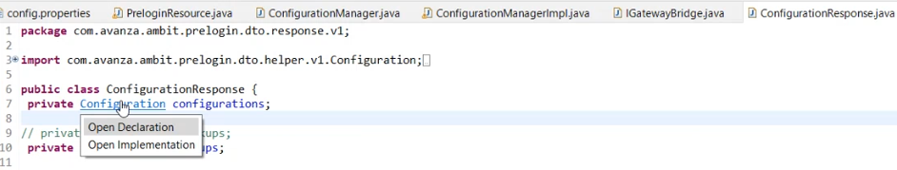

Jis k andar hamaray pass system confi and security config hai

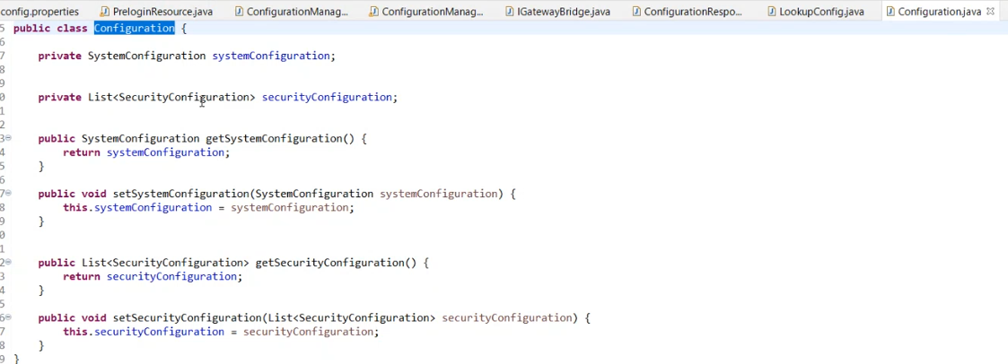

Agar hum create lead ki example dekhay ab tw is mai transaction k liye rdv use hota hai tw is liye hum transaction processor ko use kar rahay hotay hai

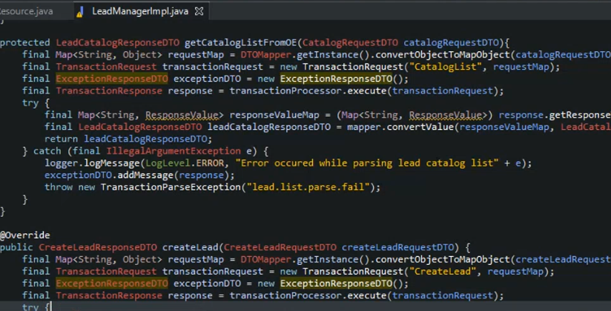

Do transaction mai hum stan generate kar rahay hotay hai

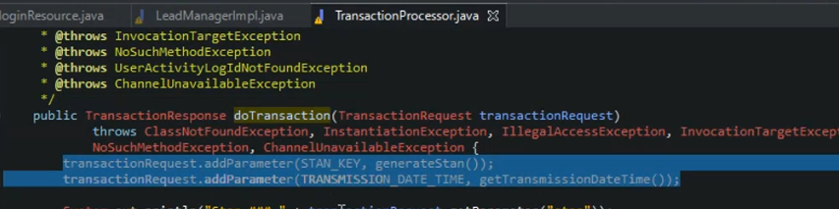

Stan code jo hai wo har transaction k liye unique hota hai or yai har din renew hota hai

Stan counter k liye hum redis ko use kartay hai redis mai hamara stan counter maintain horaha hota hai

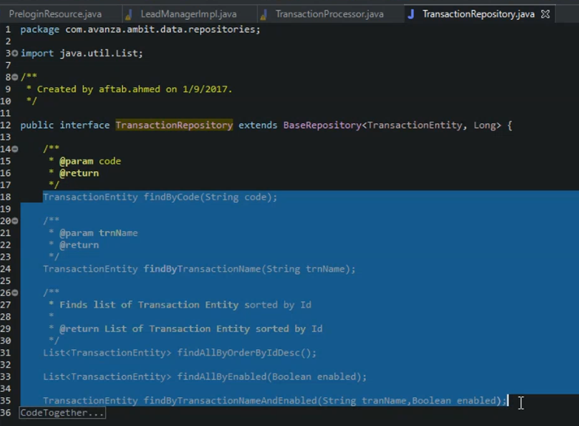

Transaction repository mai kuch methods define hoa way hai yai jo hai ORM k kuch already define hai or kuch humne apni needs k hisab sai define kia hai

Find by transaction jo hai select ki query ki find karne k liye jayega Transaction entitiy mai

Transaction entity hamare pass system transaction ka 1 table hai

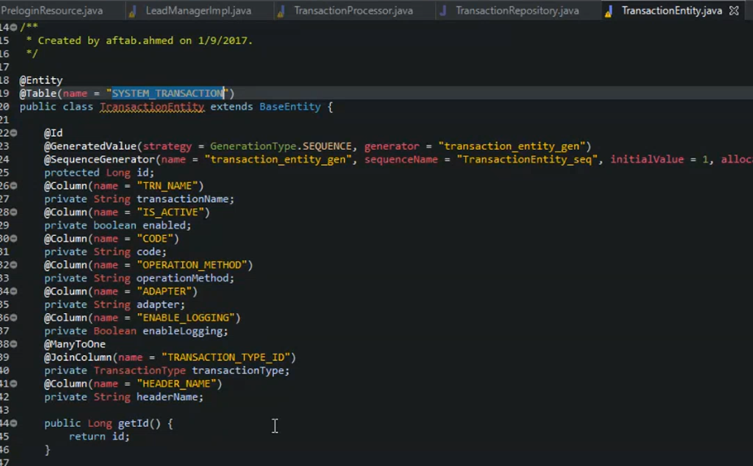

Agar aap DBViewer mai jayengay tw aap ko waha system transation ka table milay ga

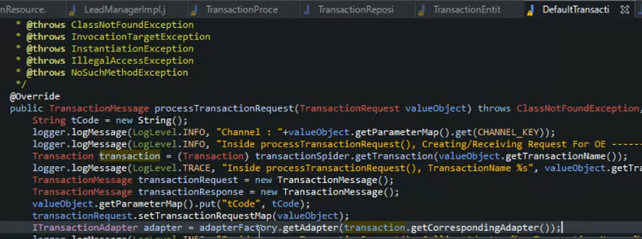

Hum yaha par adapter factory use kar rahay hai jis k andar hamray pass multiple adapter hotay hai

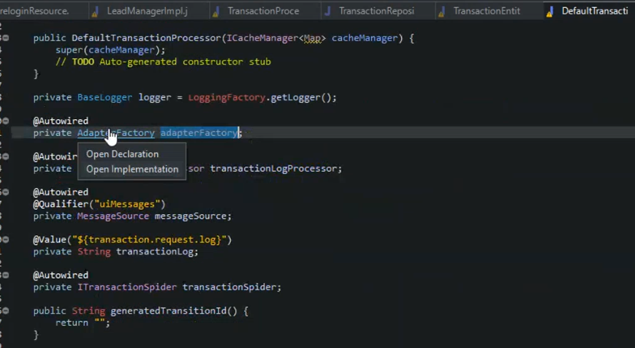

Yaha hamaray pass 1 bean hai yai humay bata rahi hoti hai k humay kis system sai connect hona hai

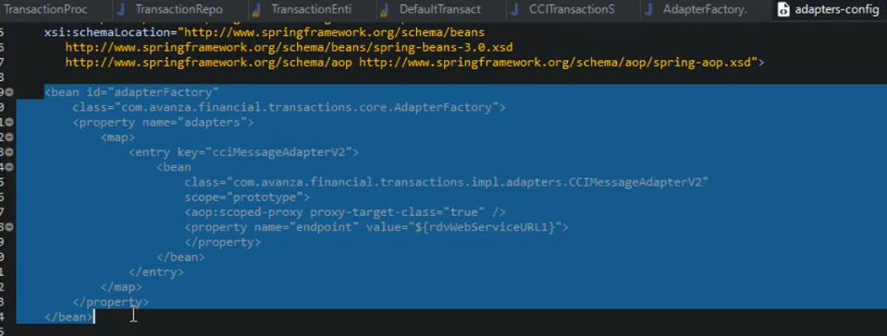

Lets say hamaray pass abhi pci message format use horaha hai jis k through hum kya kartay hai yai beam uthatay hai is beam k through hum apni transaction ko fire kartay hai yaha 1 cheez likhi hoe hai rdvwebserviceurl1 iska matlab yai k is url sai connect hona hai apni transaction ko perform karne k liye.

base class mai code message content pehlay sai hoga jo respone is k bar aks bhejna chahunga tw isko extend kardengay